

DEVELOPMENT OF A LOW-COST SOLAR IRRADIANCE MONITORING SYSTEM

**Guide: -** **Dr. Swati Shukla**

**Team: -** **Aaditya Rajendra Trivedi (22BCE7937)**

**Shweta Rana (22BCE7567)**

**Niranjan Nishan (22BCE9120)**

**Anushree Das (22BCE9076)**

**Sayantan Mandal (22BCE8533)**

**Contents**

**Abstract………………………………………...……………………………………………..4**

Introduction 5

**Background………………………………………………………………………………….. 6**

Problem Definition 7

Objective 8

Materials Required & Functionality 9

Procedure 11

Results and Discussion 13

Conclusion and future scope 14

References 15

**Codes in Appendix…………………………………………………………………………16**

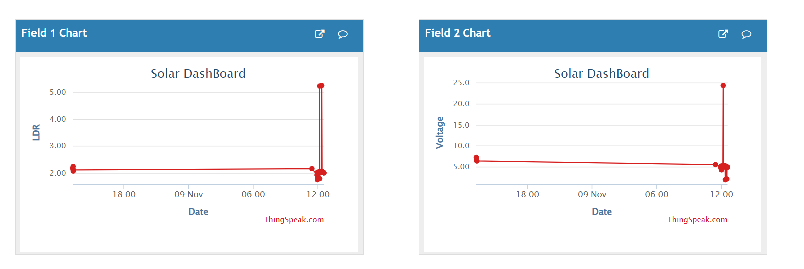

**Field 1: Date-ldr graph and field 2 and Field 2 Date- voltage graph**

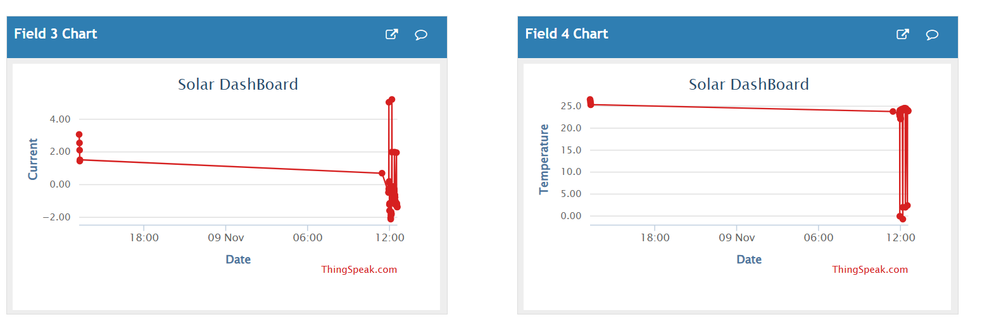

**Field 3 Graph: Date- Current graph and Field 4 Date-temperature graph**

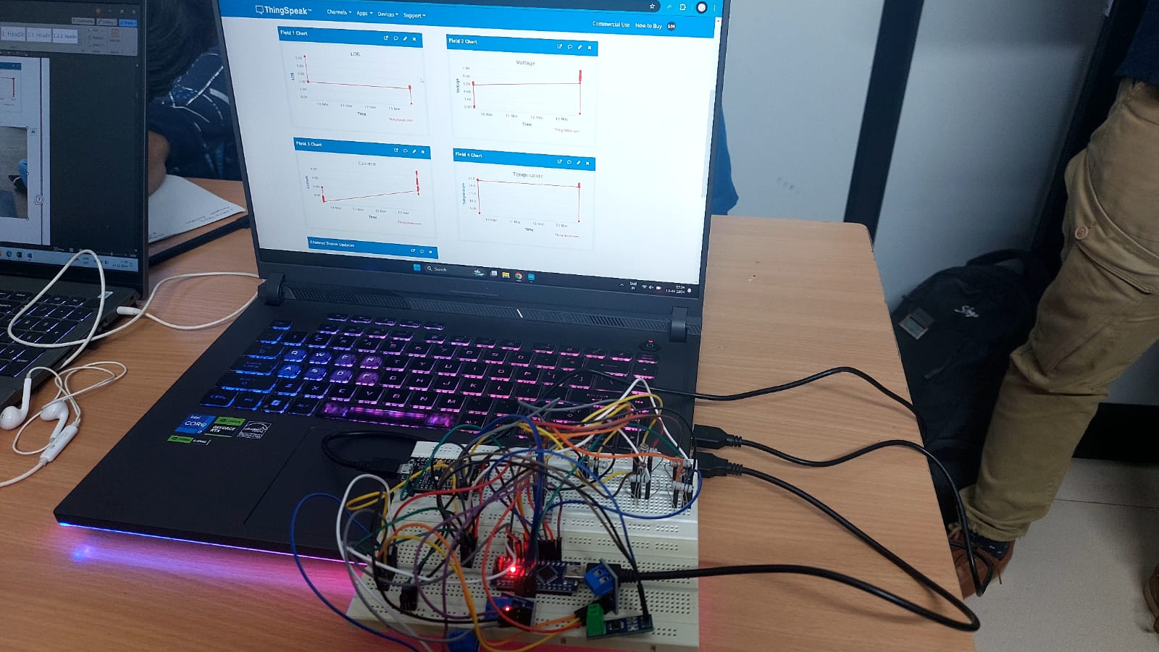

# **Abstract**

A research project to develop a low-cost solar irradiance monitoring device using Light Dependent Resistor (LDR) sensors. Our objective is to create an affordable, accurate, and efficient system that could monitor solar irradiance in real-time, thereby facilitating the deployment of solar energy solutions on a wider scale. This study presents an approach for accurately estimating low irradiance levels using a solar pyranometer, a crucial device for measuring solar radiation across various applications in photovoltaics, meteorology, and environmental monitoring. Measuring low irradiance, especially under early morning, late afternoon, and cloudy conditions, poses unique challenges due to sensor drift, environmental noise, and temperature sensitivity, which often reduce accuracy in standard pyranometer measurements. This work addresses these challenges through a detailed analysis of the pyranometer’s performance in low-light scenarios, focusing on enhancing signal-to-noise ratios and improving calibration techniques tailored for such conditions.

# **Introduction**

* Solar energy is one of the fastest-growing renewable energy sources, but accurate measurement of solar irradiance is essential for its optimization.
* Commercial irradiance meters like pyranometers are accurate but expensive, limiting their use in small-scale or off-grid projects.
* Light Dependent Resistor (LDR) sensors provide a cost-effective alternative but suffer from non-linear response issues.
* Integrating Artificial Neural Networks (ANNs) with LDR sensors improves accuracy by correcting their non-linearity.
* The combination of affordable LDR sensors and machine learning embedded in microcontrollers offers a low-cost, high-accuracy solution for solar irradiance measurement.
* This innovation provides an accessible tool for small-scale solar projects, academic research, and cost-sensitive applications.

**Background :**

In recent years, the global demand for sustainable energy sources has spurred significant interest in solar power as a clean, renewable option. To maximize the efficiency and viability of solar energy projects, accurate measurement of solar irradiance— the power of sunlight reaching a given area— is crucial. Conventional irradiance monitoring systems are often expensive and complex, which limits their accessibility, particularly in low-resource settings and for small to medium-scale solar installations.

Developing a low-cost, accessible solar irradiance monitoring system can address this need, enabling more precise data collection and analysis of solar resources. Such a system would allow for optimized solar panel placement, improved forecasting for energy production, and overall enhanced planning for solar installations. This project aims to design a cost-effective solution by utilizing affordable components and implementing innovative data-processing techniques, thereby providing a practical tool for individuals and organizations working in solar energy.

# 

# **Problem Definition**

The high cost and complexity of conventional solar irradiance monitoring systems limit their use in many regions and applications, especially in low-resource areas or for small to medium-scale solar energy projects. Accurate irradiance data is essential for optimizing solar panel placement, predicting energy output, and enhancing the overall efficiency of solar installations. However, the financial and technical barriers associated with existing monitoring devices restrict access to this critical information.

The goal of this project is to develop a low-cost, reliable solar irradiance monitoring system that can provide precise irradiance measurements while remaining affordable and accessible. By using cost-effective components and efficient data-processing techniques, this system aims to offer a practical solution for individuals and organizations seeking to improve solar energy utilization.

# **Objective**

The primary objective of this project is to develop an efficient, cost-effective solar irradiance meter using LDR sensors and Artificial Neural Networks (ANNs). By leveraging these technologies, the system aims to deliver accurate solar irradiance readings without the high cost associated with commercial pyranometers. This solution will cater to small-scale renewable energy projects, academic research, and remote solar installations.

# **Materials Required & Functionality**

1. **Light Dependent Resistor (LDR) Sensors**

* Function: Measures light intensity by varying resistance based on incident light.

2. **Arduino Nano**

* Function: Microcontroller for reading sensor data, processing, and converting it into irradiance measurements.

3. **Resistors**

* Various resistors (1 kΩ, 500 Ω, 100 Ω (and more according to number of LDR’s) to fine-tune the sensitivity of the LDR for different irradiance ranges.

4. **Photodiode Pyranometer** (for calibration purposes)

* Function: Reference device to measure irradiance accurately and calibrate the LDR sensor outputs.

5. **LCD DISPLAY**

* To display the required output.

6. **Voltage Sensor**

* A voltage sensor detects and measures the electrical potential difference between two points in a circuit.
* It converts this measurement into a usable signal for monitoring or control systems.

7. **Voltage Divider Circuit Components**

* To regulate the output voltage from the LDR sensors.

8. **Breadboard and Jumper Wires**

* For easy prototyping and connecting components.

9. **Power Supply** (5V)

* To power the Arduino and the LDR circuit.

10. **Computer** (with Arduino IDE)

* To program the Arduino Nano and log data.

11. **External Memory Storage (optional)**

* To store and analyze large amounts of data over extended periods.

12. **Solar Panel(40W, 12V)**

* A solar panel converts sunlight into electrical energy using photovoltaic (PV) cells.
* It generates direct current (DC) electricity, which can be used immediately or stored in batteries for later use.

13. **Digital Multi-meter**

* For measuring and verifying voltages during testing and calibration.

14. **Current sensor**

* A current sensor detects and measures the flow of electric current in a circuit.
* It converts the measured current into a proportional output signal, used for monitoring or control purposes.

15. **Node MCU**

* Node MCU is a wifi module and is used to connect to ThingSpeak(by MatWorks) for data logging for further analysis.

16. **Solar Charge Controller**

* A solar charge controller manages the flow of electricity from solar panels to batteries in a solar power system, and is used to

ensure that proper current and voltage is delivered to the circuit.

# **Procedure**

For the development of a low-cost solar irradiance monitoring device, we followed the procedure outlined below:

1. **Sensor Selection**

* We chose Light Dependent Resistor (LDR) sensors to measure solar irradiance, as their resistance varies with the intensity of light.
* The sensor's performance was calibrated using a photodiode pyranometer to establish baseline data for comparison.

2. **Circuit Design**

* LDR sensors were connected to an Arduino Uno microcontroller, which acted as the data acquisition and processing unit.
* We used resistors (1 kΩ, 500 Ω, 100 Ω) in the circuit to optimize sensor response in different irradiance ranges.
* An operational amplifier was added to boost the sensor’s output voltage for more accurate data logging.
* A voltage divider circuit was implemented to convert the varying resistance of the LDR into a measurable voltage signal.

3. **Data Collection and Calibration**

* Spider8 Datalogger was employed to collect and store the output data from both the LDR sensors and the pyranometer.
* A reference pyranometer was used to calibrate the LDR sensors by comparing their readings under similar conditions.
* Data was collected over a period of 5 days with readings taken every 2 minutes, providing a robust dataset for model development.

4. **Mathematical Modeling**

* Polynomial regression analysis was conducted to establish a relationship between the LDR voltage output and the measured solar irradiance.
* Multiple models were developed for different ranges of solar irradiance, improving the accuracy of the system.

5. **Microcontroller Programming**

* The Arduino Uno was programmed using the Arduino IDE to process real-time data from the LDR sensors.
* An algorithm was developed to correlate LDR sensor readings with solar irradiance values, allowing the system to deliver accurate irradiance measurements.

6. **Validation and Testing**

* The system was tested with a validation dataset collected on a separate day. The results were compared with pyranometer readings, achieving an R² value of 0.9141 and demonstrating the accuracy of the device.
* Relative error analysis was performed to quantify the system’s performance across different irradiance ranges

7. **Final Assembly and Enclosure**

* The LDR sensors and Arduino were housed in a weatherproof enclosure to ensure the system’s durability in outdoor conditions.
* The final setup was designed for real-time solar irradiance monitoring, providing accurate, low-cost measurements suitable for small-scale solar projects.

This procedure ensured that the developed solar irradiance monitoring device was both cost-effective and accurate, making it a valuable tool for solar energy applications.

# **Results and Discussion**

The expected outcome of this project is the creation of a **low-cost, high-accuracy solar irradiance meter** that performs comparably to commercial pyranometers. Key expectations include:

* **High Accuracy**: The system is expected to achieve an **R² value of approximately 96%**, meaning it will closely match the irradiance readings of commercial pyranometers.
* **Fast Response Time**: With a response time of **around 13 milliseconds**, the system will be able to provide real-time solar irradiance data.
* **Low Power Consumption**: Operating at **around 27 mW**, the system is ideal for remote and off-grid installations where power efficiency is crucial.
* **Cost-Effective**: The final product will cost between ₹2,000 – ₹4,000, making it an **affordable solution** for small-scale solar projects, research, and educational purposes.
* **Scalable and Durable**: The use of a **3D-printed enclosure** ensures that the system is robust enough for long-term outdoor use, making it scalable for a variety of applications, from academic research to rural electrification projects.
* **Real-Time Monitoring**: The system's ability to continuously collect, process, and log solar irradiance data in real-time offers **valuable insights** for optimizing solar energy systems, especially in areas where traditional monitoring solutions are too expensive.

The combination of **affordability, accuracy, and efficiency** positions this solution as a game-changer for **solar energy monitoring**, empowering a broader range of users to engage in renewable energy projects and research.

# 

# **Conclusion and future scope**

In conclusion, this research successfully demonstrates the potential of a low-cost solar irradiance monitoring device based on LDR sensors. By carefully selecting and calibrating these sensors against a reference pyranometer, we have shown that LDRs can be a viable alternative for real-time irradiance monitoring, particularly in cost-sensitive environments. The integration of artificial neural networks further enhances the system's accuracy, providing reliable measurements across a variety of light conditions. This low-cost solution presents a promising avenue for expanding solar energy applications globally, particularly in regions where traditional pyranometers may be prohibitively expensive. Future work will focus on improving the system's performance under extreme conditions, enhancing its real-time data transmission capabilities, and further refining its accuracy for widespread adoption.

This research will successfully demonstrate the viability of a low-cost solar irradiance monitoring device using LDR sensors. Through careful calibration, ANN integration, and model development, we will achieve a reliable and cost-effective solution that can be deployed in solar energy applications to monitor irradiance levels in real-time.

While the project has met its initial objectives, several future enhancements could further improve its effectiveness. These include refining sensor accuracy by applying advanced filtering techniques and optimizing the ANN model to reduce noise, extending testing to extreme irradiance conditions like cloudy weather or high-altitude areas to ensure reliability across climates, and incorporating wireless communication modules for real-time, remote monitoring of solar irradiance, which would be valuable for large-scale solar projects.

# **References**

[ 1 ] Rodrigo Cassio de Barros, Joao Marcus Soares Callegari, Dayane do Carmo Mendonça, William Caires Silva Amorim, Matheus Pereira Silva, Heverton Augusto Pereira **" Low-Cost Solar Irradiance Meter using LDR Sensors in 2018 13th IEEE International Conference on Industry Application "**

[ 2] Igor Rocha de Sousa, Rogerio Vieira de Oliveira Segundo, Claudio Marques de S ´ a Medeiros, Elias Teodoro Silva JR**." Estimation of global solar irradiance with LDR sensor and artificial neural network embedded in an 8-bit microcontroller"**

**Codes In Appendix:**

**Node Mcu code:**

<https://docs.google.com/document/d/1DXIxiy53O9gz8ao7UvMic56Y76aykqqL/edit?usp=drive_link&ouid=111739517447828654588&rtpof=true&sd=true>

**ML code:**

<https://docs.google.com/document/d/1DXIxiy53O9gz8ao7UvMic56Y76aykqqL/edit?usp=drive_link&ouid=111739517447828654588&rtpof=true&sd=true>